LED strip
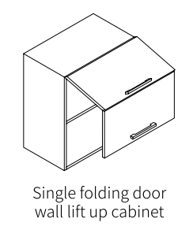
Shelves inside for spices
3,5 cm higher because of: 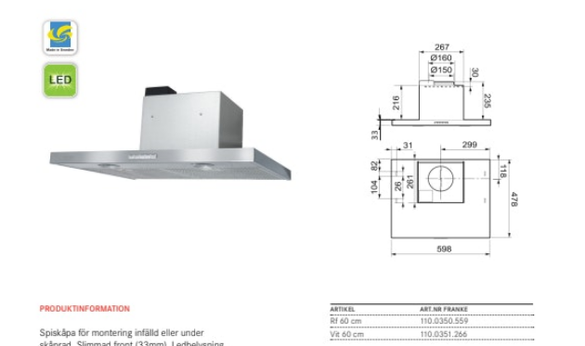
LED strip
LED strip vertical on right side
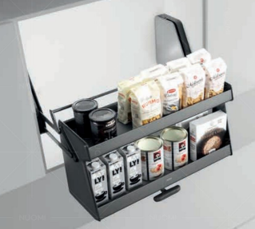 Nuomi 2024
P 109
4188005
Nuomi 2024
P 109
4189005
Nuomi 2024
P 109
4188005
LED strip
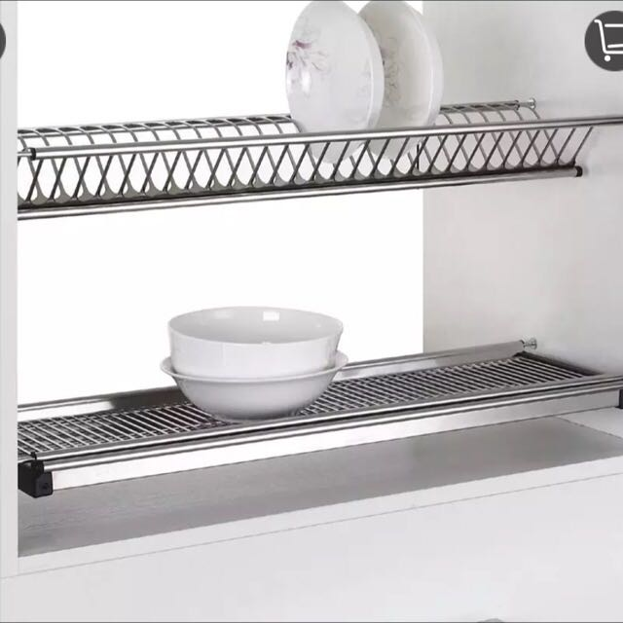
No bottom wood in this cabinet, Dish rack empties into sink
Pullout 80 cm recycling sorting
Nuomi 2024
P. 225
3012001

60 cm 3 drawers high class

Dishwasher 60

90 cm 3 drawers high class
Drawer for oven racks
Nuomi 2024
P. 98
3184019

