Start with removing battery and top cover.
Removing of battery is described in user manual. After you successfully removed the battery
Unscrew four bolts holding top cover (marked with red circles)
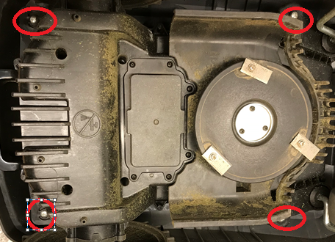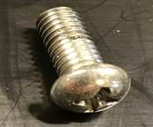

Once battery and bolts are removed turn your robot and lift top cover and set it aside (it is still connect with robot via 2 cables from sensor).
You should get something like this:
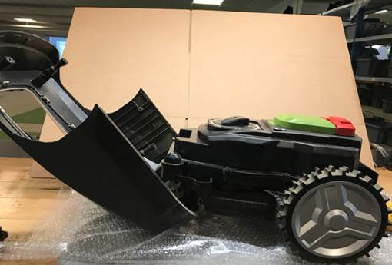

To open the robot remove all screws around the top body and all screws from cutting height unit (20 in total, see pictures below)
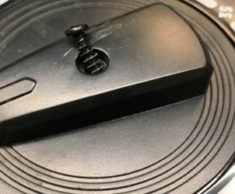BE AWARE THAT PARTICULAR SCREW BELONG TO THE CAP, DO NOT REPLACE IT WITH OTHER ONES
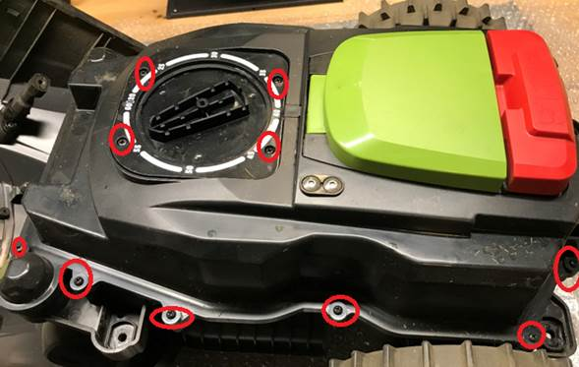

OR if another version
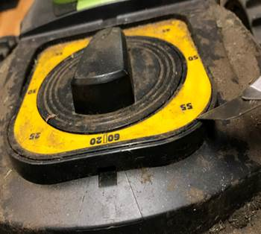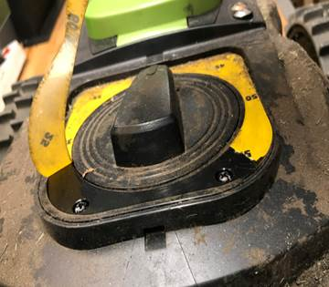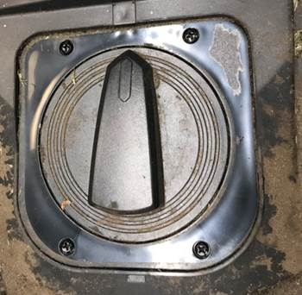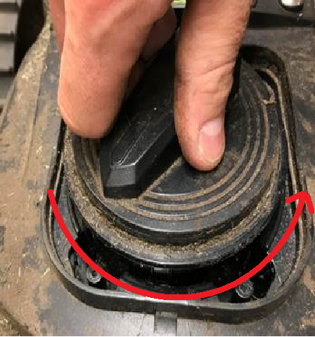

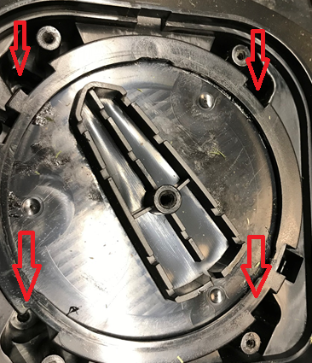

Once all screws are removed you can open the robot.
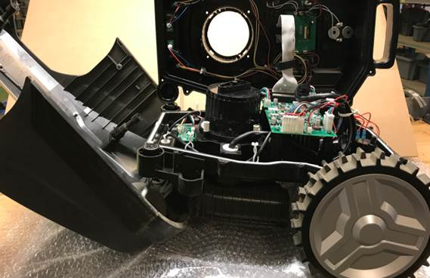

Back up battery is a standard CR1220, mounted in a corner of PCB button battery holder.
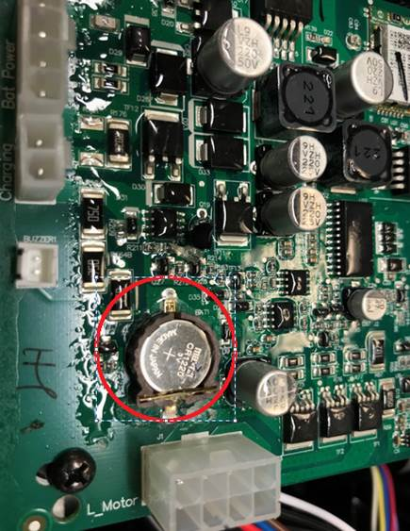
After removing and replacing CR1220 undo the whole process to assembly robot.

